 | Turing Machines Worksheet | 

For this activity you are required to fill in the contents of the tape for each of the Turing Machines provided below. You may wish to print this document or if you prefer you could complete the exercise just using pencil and paper.

Turing Machine 1.
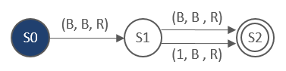

State | Tape contents
S0 | 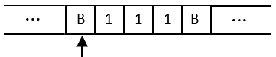
S1 | 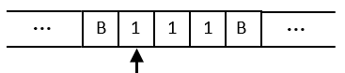

You can continue from here – there’s only one step left!

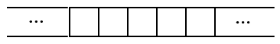

What does this Turing Machine do? __________________________________________

Note: If, as a group, you are not sure how to complete this exercise you should study the example provided on the last page of this document – this is the same example that was demonstrated using slides in the workshop.

Turing Machine 2
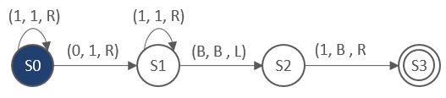

State | Tape contents
S0 | 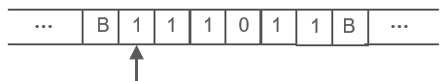
 | 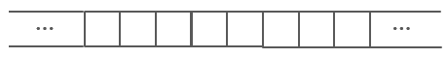
What does this Turing Machine do? __________________________________________
Turing Machine 3
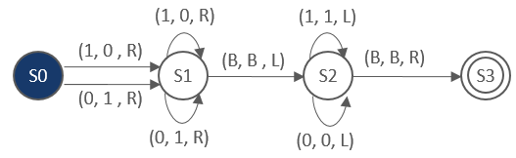

State | Tape contents
S0 | 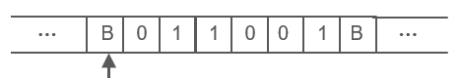

State | Tape contents

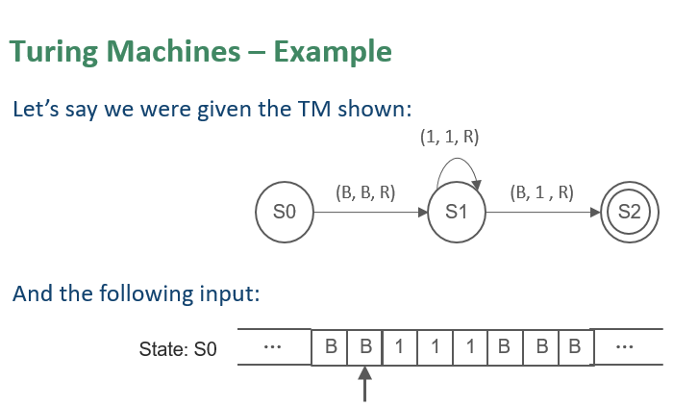
The sequence below depicts the changes to the contents of the tape as the operation of the example Turing Machine (shown above) is played out.

The initial state (above) is S0.  The r/w head is looking at a Blank. The transition rule states to write a blank, move right and change to state S1 | 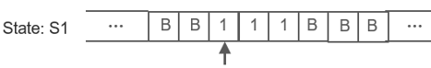
The machine state is S1  The r/w head is now looking at a 1. The transition rule states to write a 1, move right and remain in state S1 | 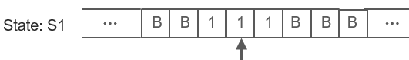
Ditto | 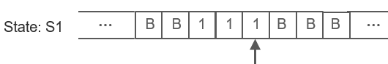
Ditto | 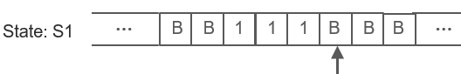
The r/w head is now looking at a B. We are still in state S1. The transition rule states to write a 1, move right and CHANGE to the final state, S2 | 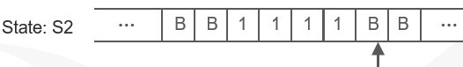

NOTES

